Science Fair Project Packet

Table of Contents
Introduction 1
Getting Started 2

Types of Projects 2

The Scientific Method 3

Choosing a Category 4

Making a Good Question 5

Guide to Research &Hypothesis 6

Recording My Own Research & Hypothesis 7

Steps to Doing the Experiment 8

Steps to Collecting Data 9

Materials, Variables, and Procedures 10

Recording Data 11

Display 12
Log Book Instructions 13

Log Book Checklist 14
Written Report Instructions 15
Science Fair Project Rubric 16

Introduction:

It’s that time again! Every year we come to the time set aside for science fair, and this nifty guide was created to help you through the entire process. But first, why do a science fair project? Science fair projects help to promote critical thinking, problem solving, and research. Not only that, but it is also interdisciplinary. This means that you do a little bit of every core subject when you complete a science fair project. Your written portions consist of ELA concepts. Your charts and graphs consist of mathematical concepts. Your research of the scientists who may have worked on something similar to your project consist of social studies/history concepts. There is so much to gain from working through and completing a science fair project!

You will have all summer to complete your project. Projects are due when we return to school from summer break. Your science teacher will provide you with instructions on the first day of class on submission information. If you have any questions while completing your project, your teacher can be reached via email.

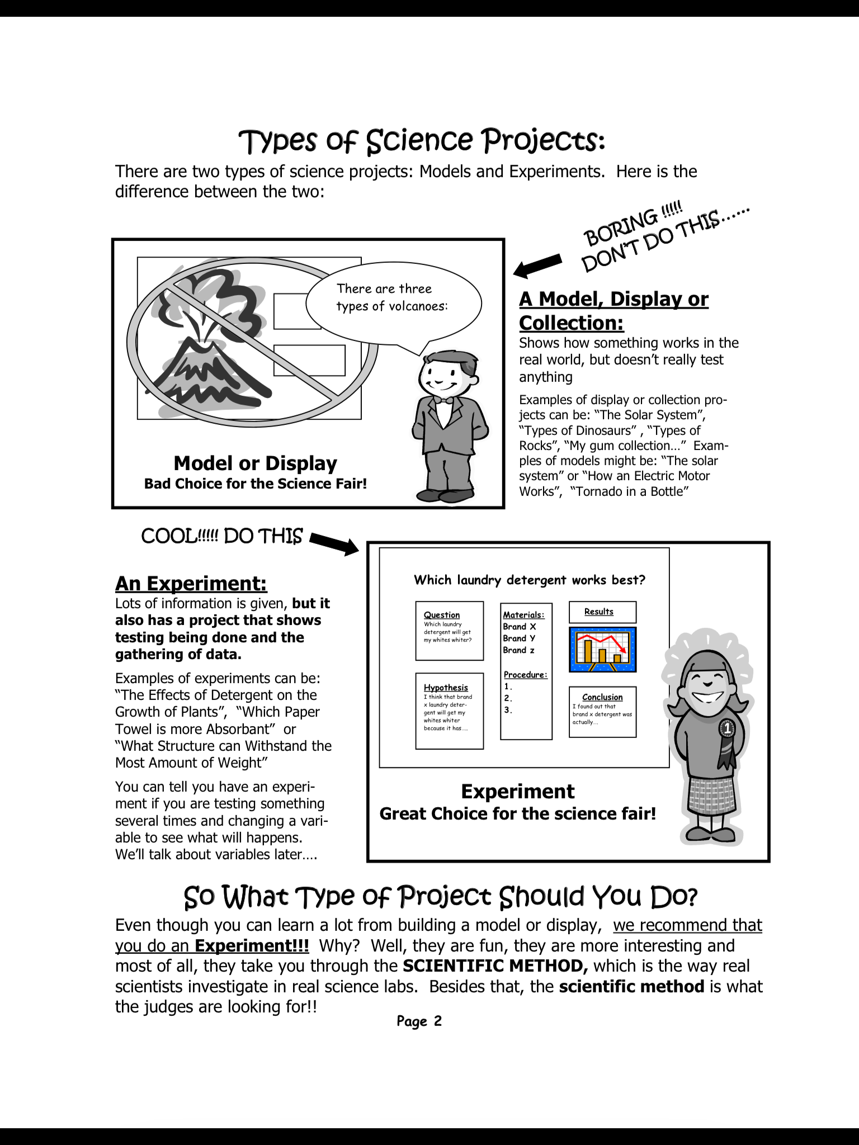
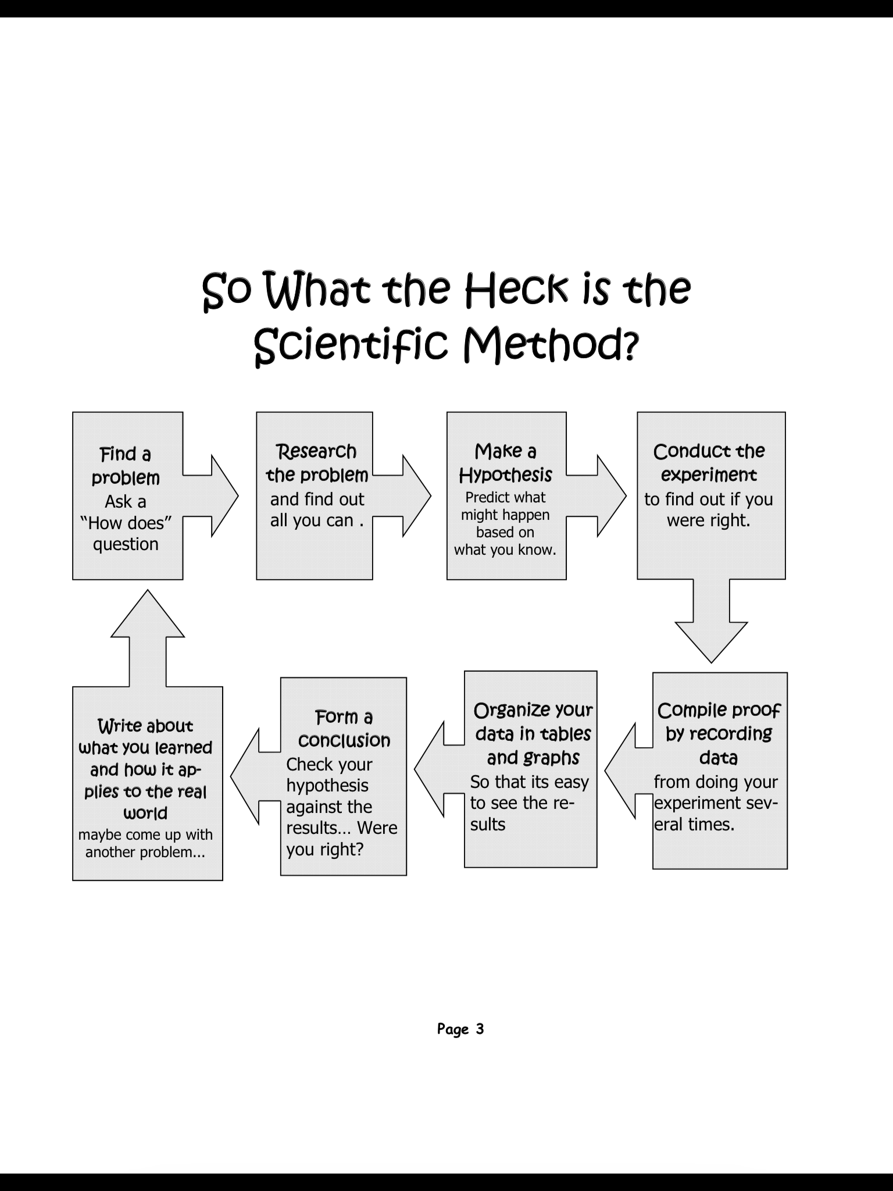
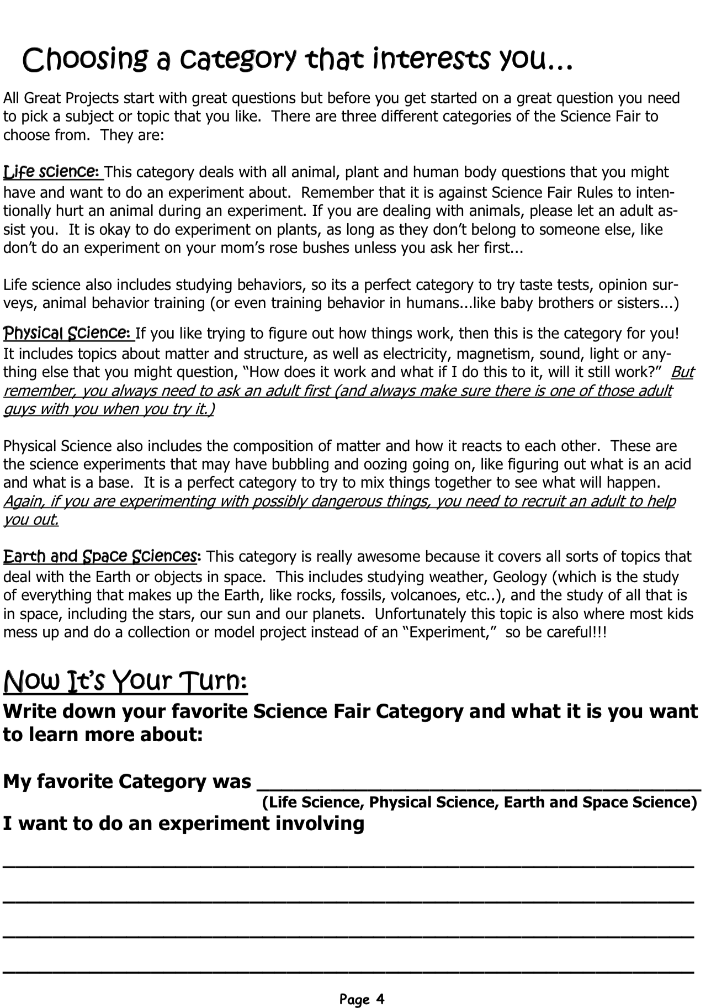

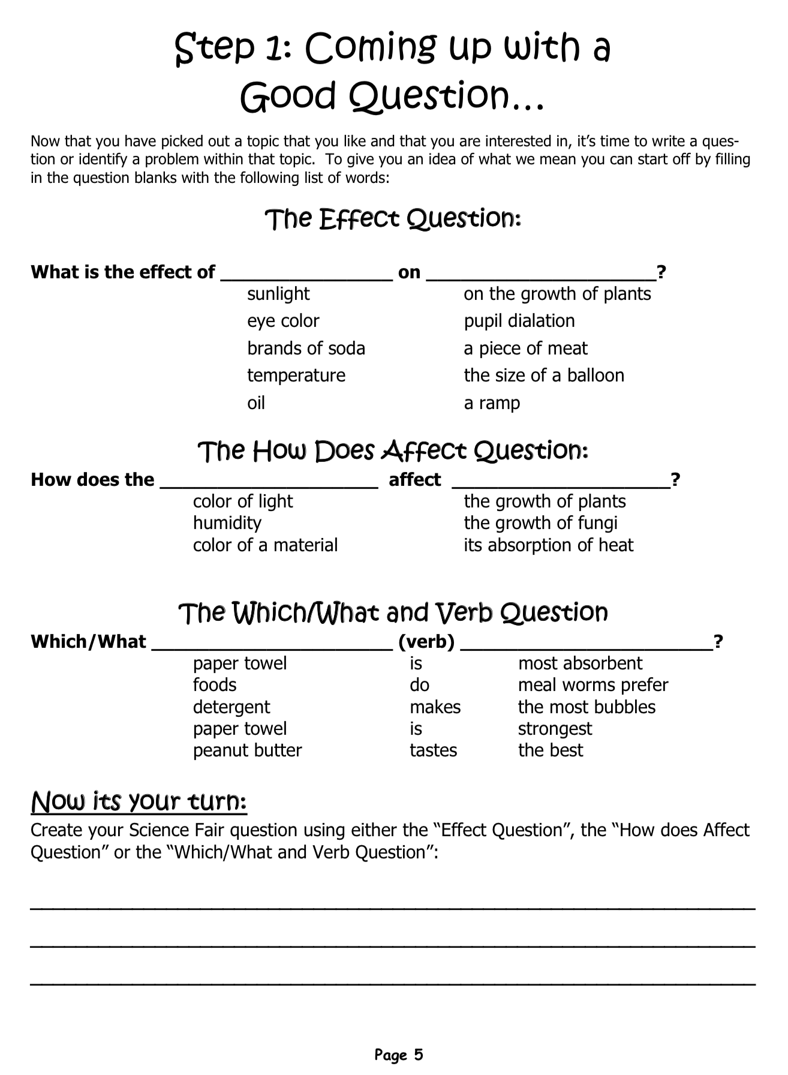

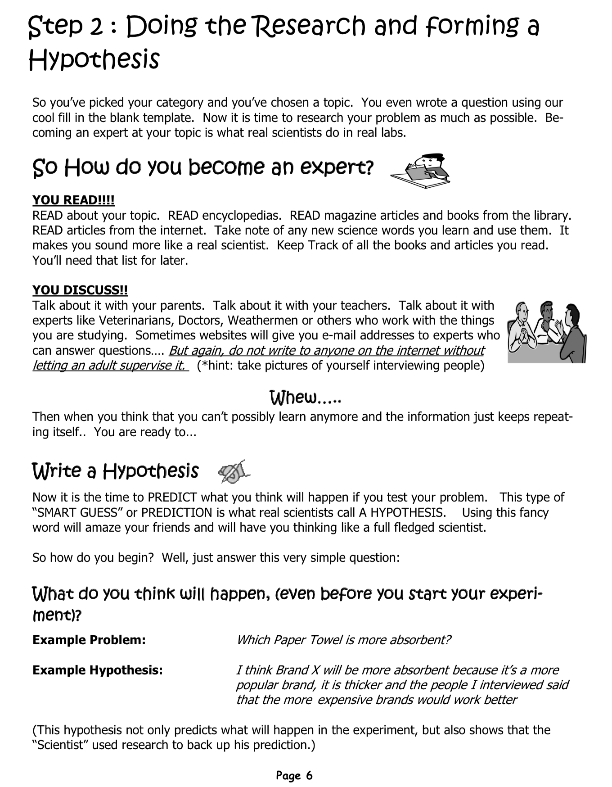

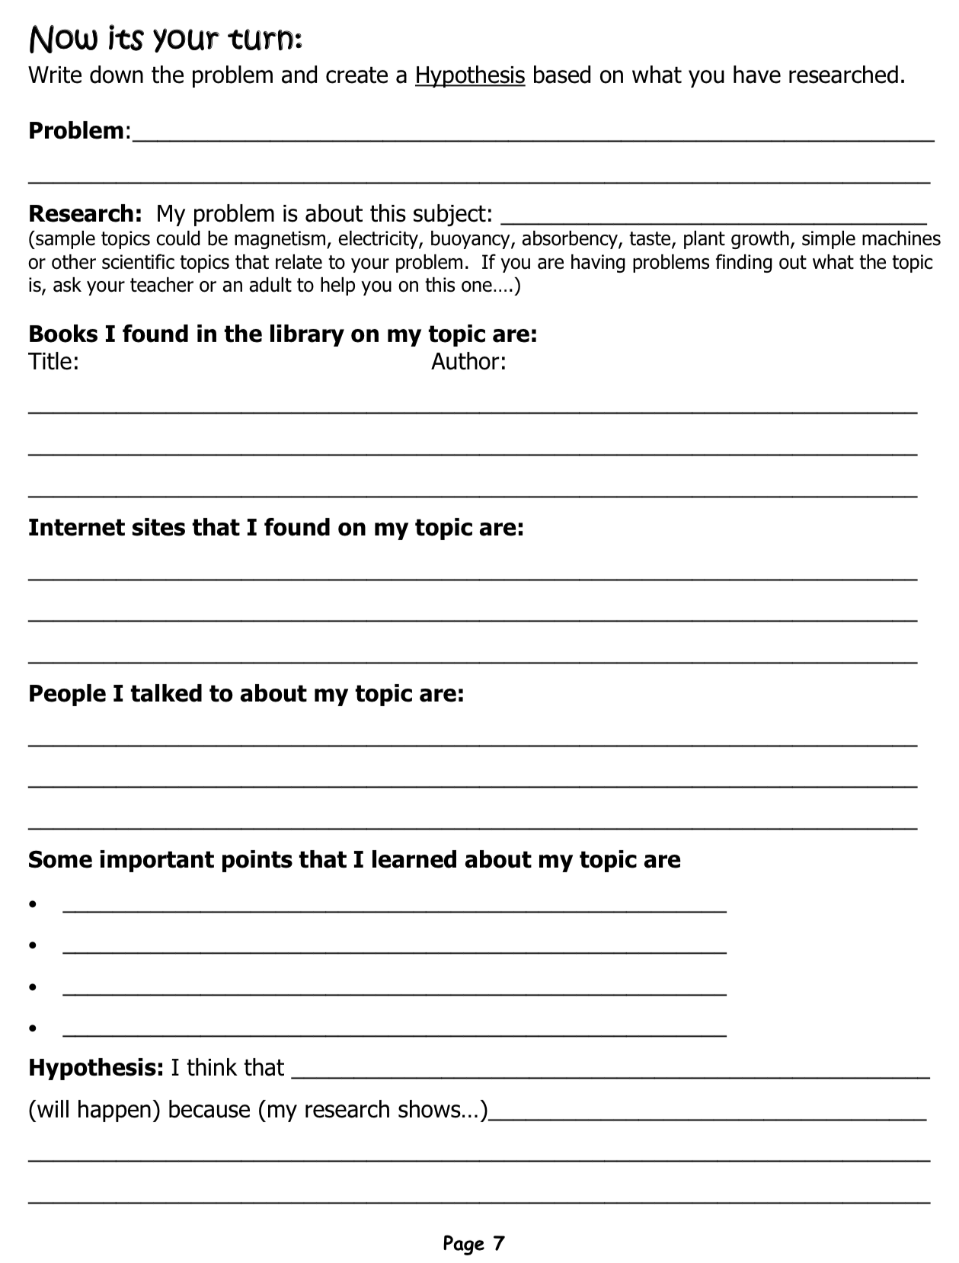
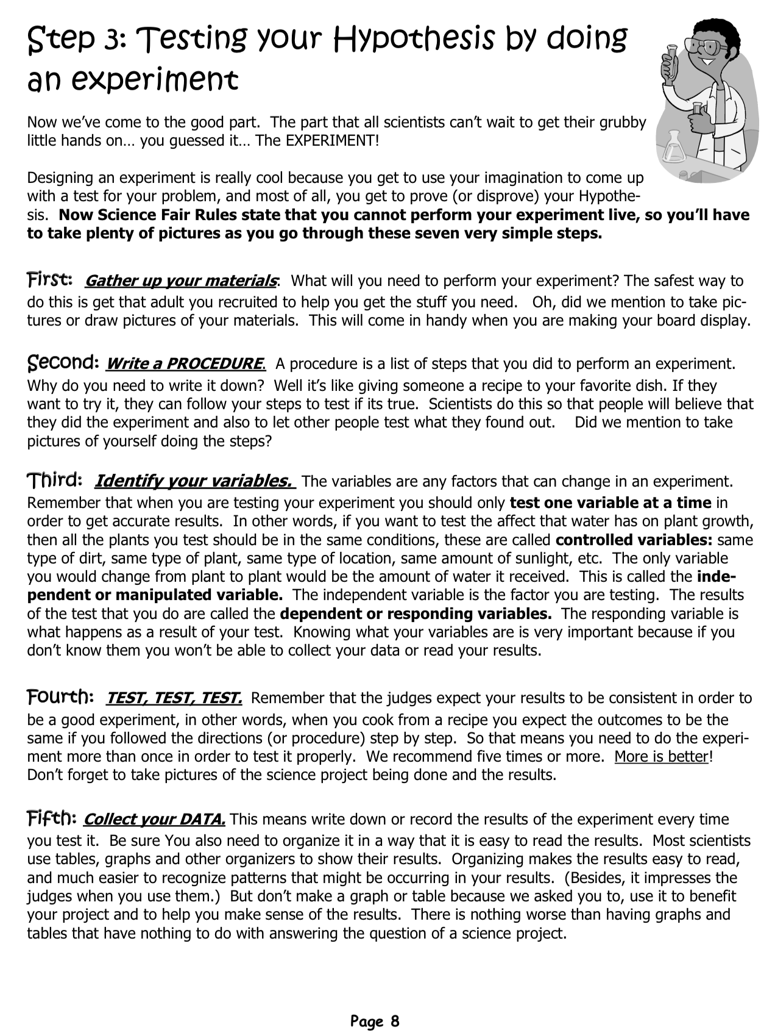
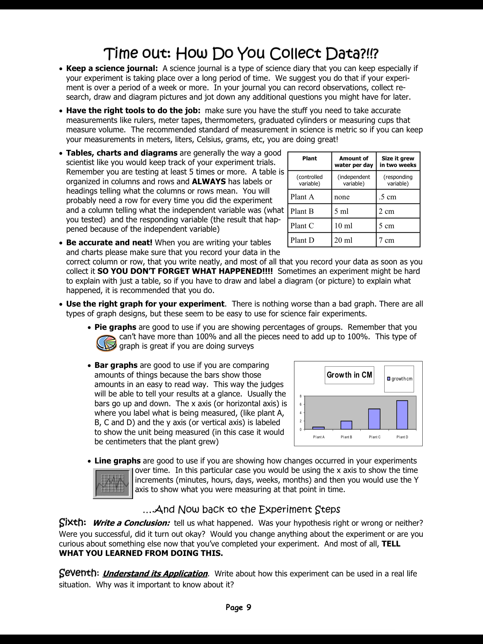

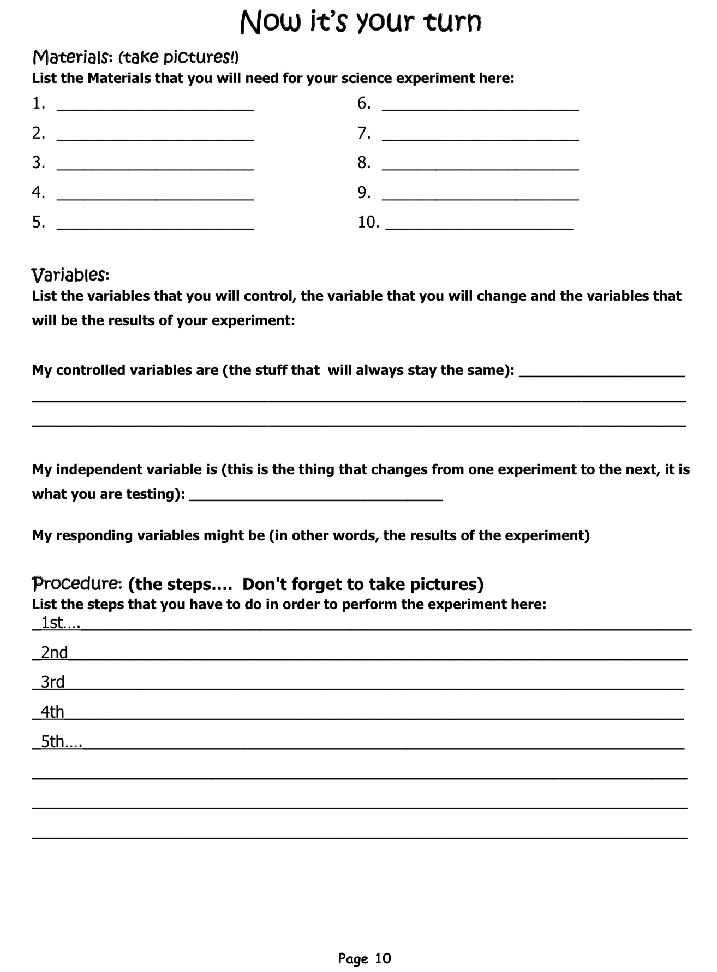

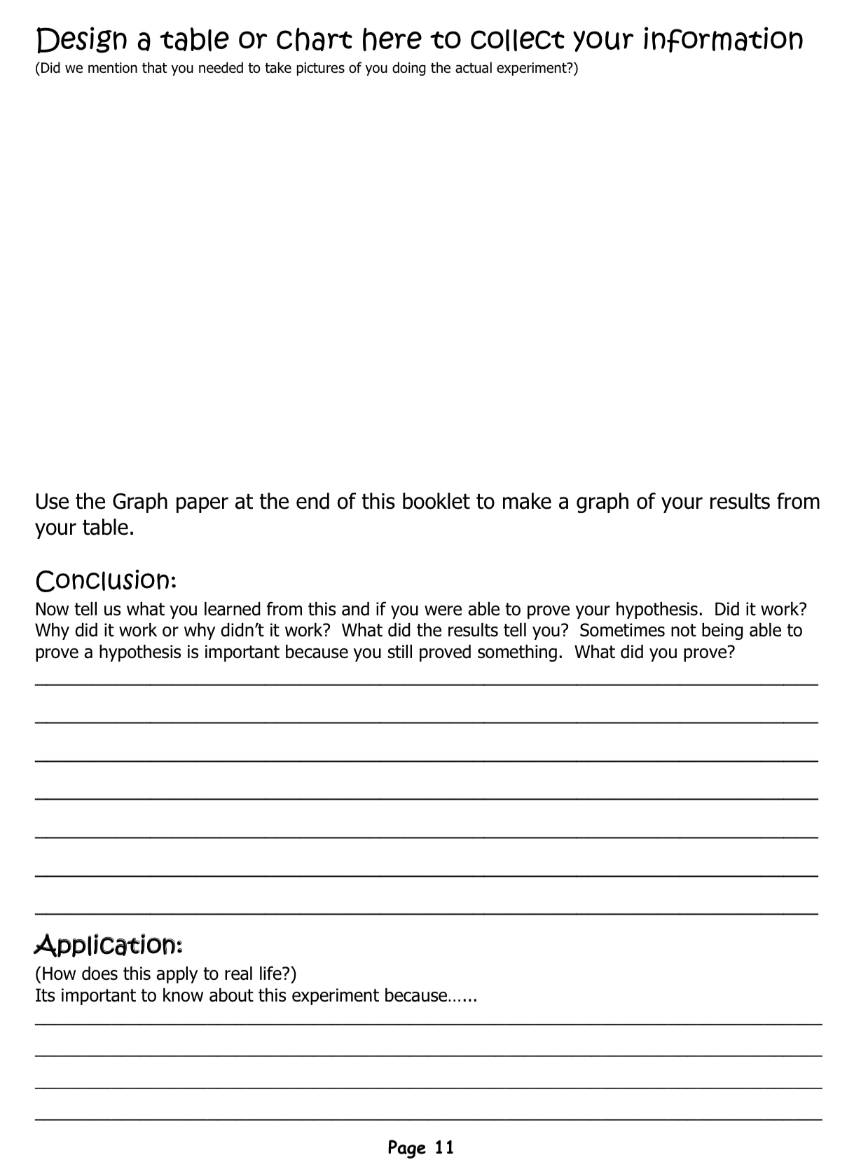

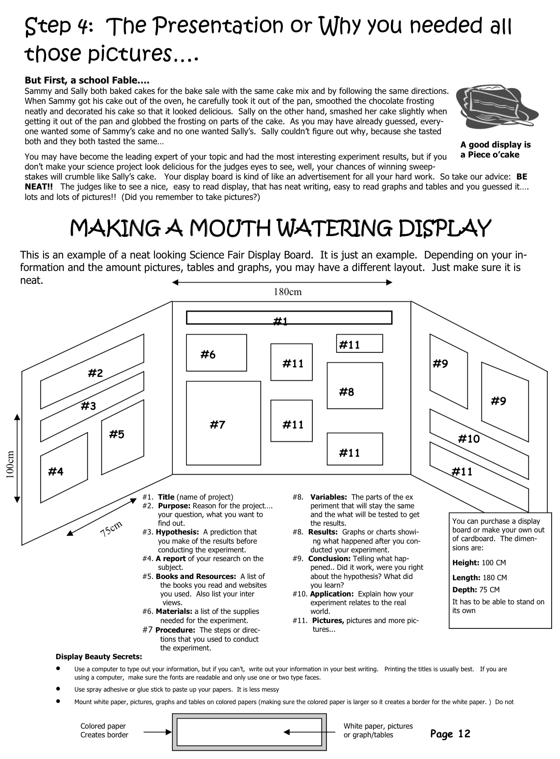

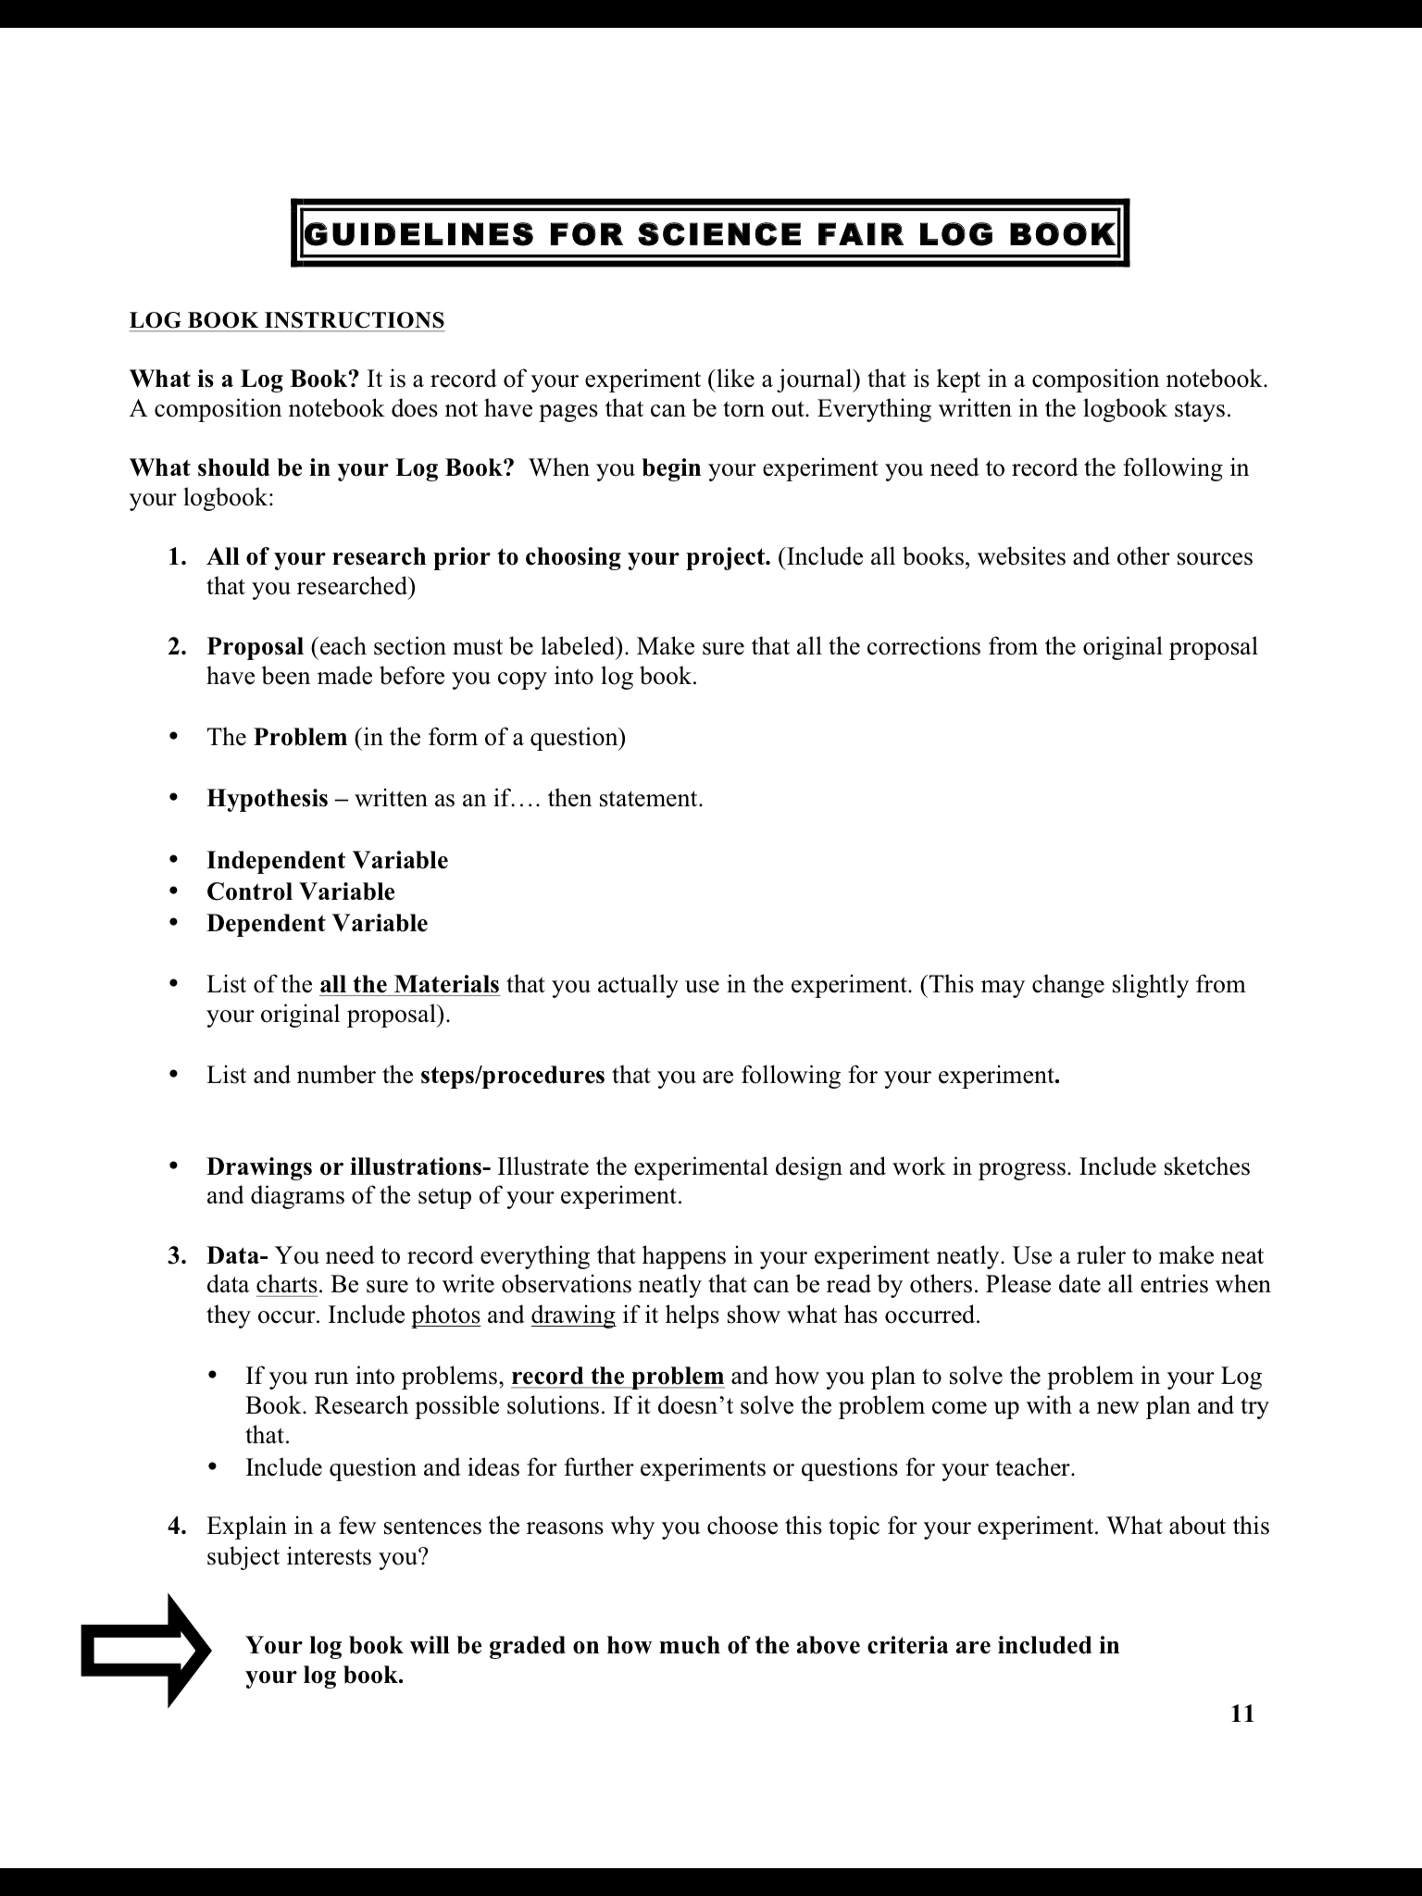

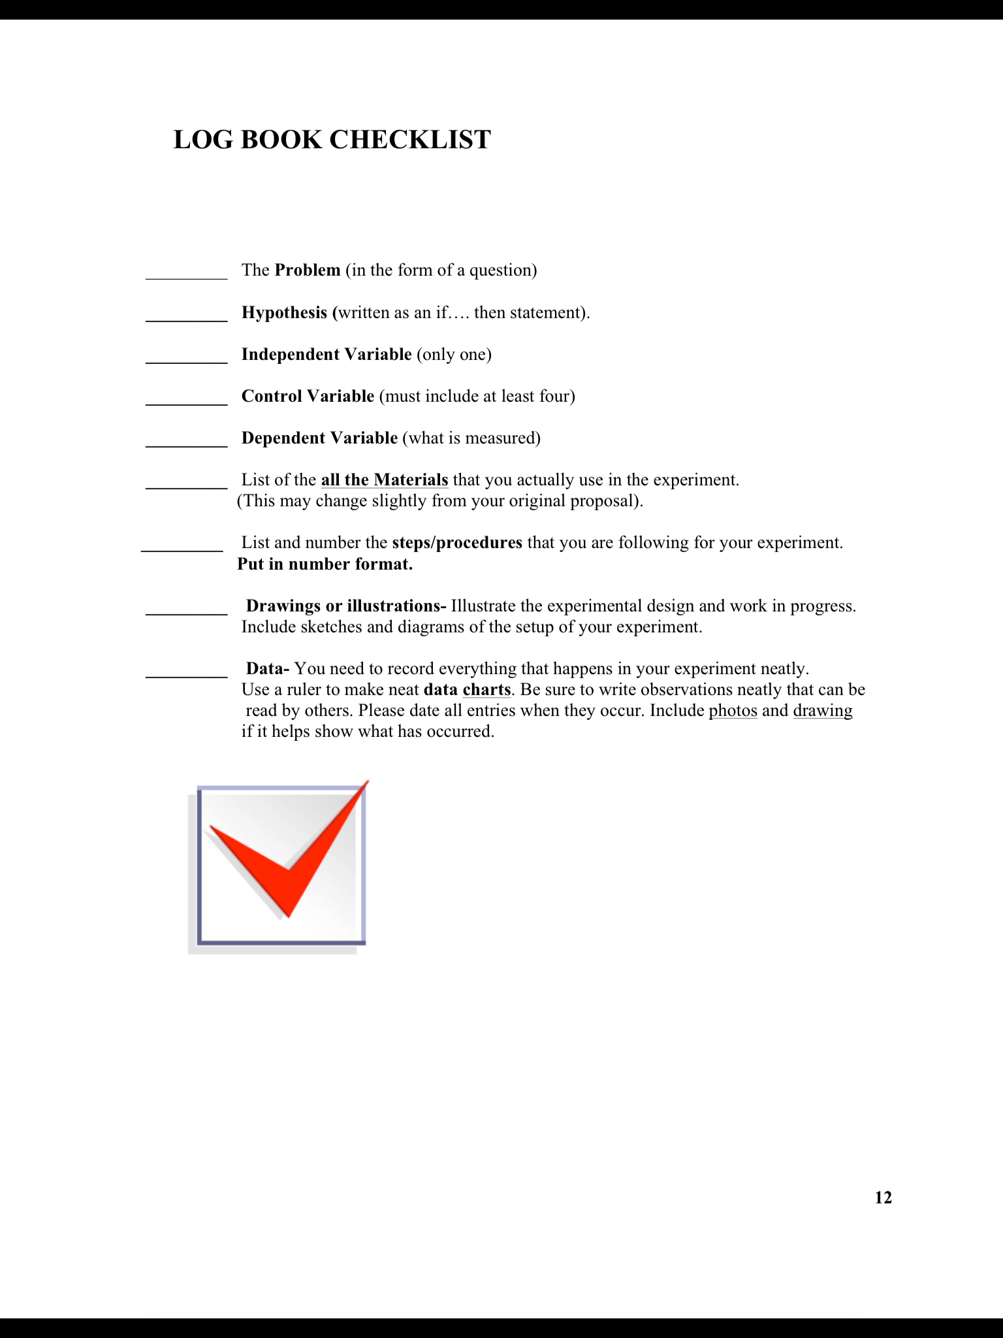

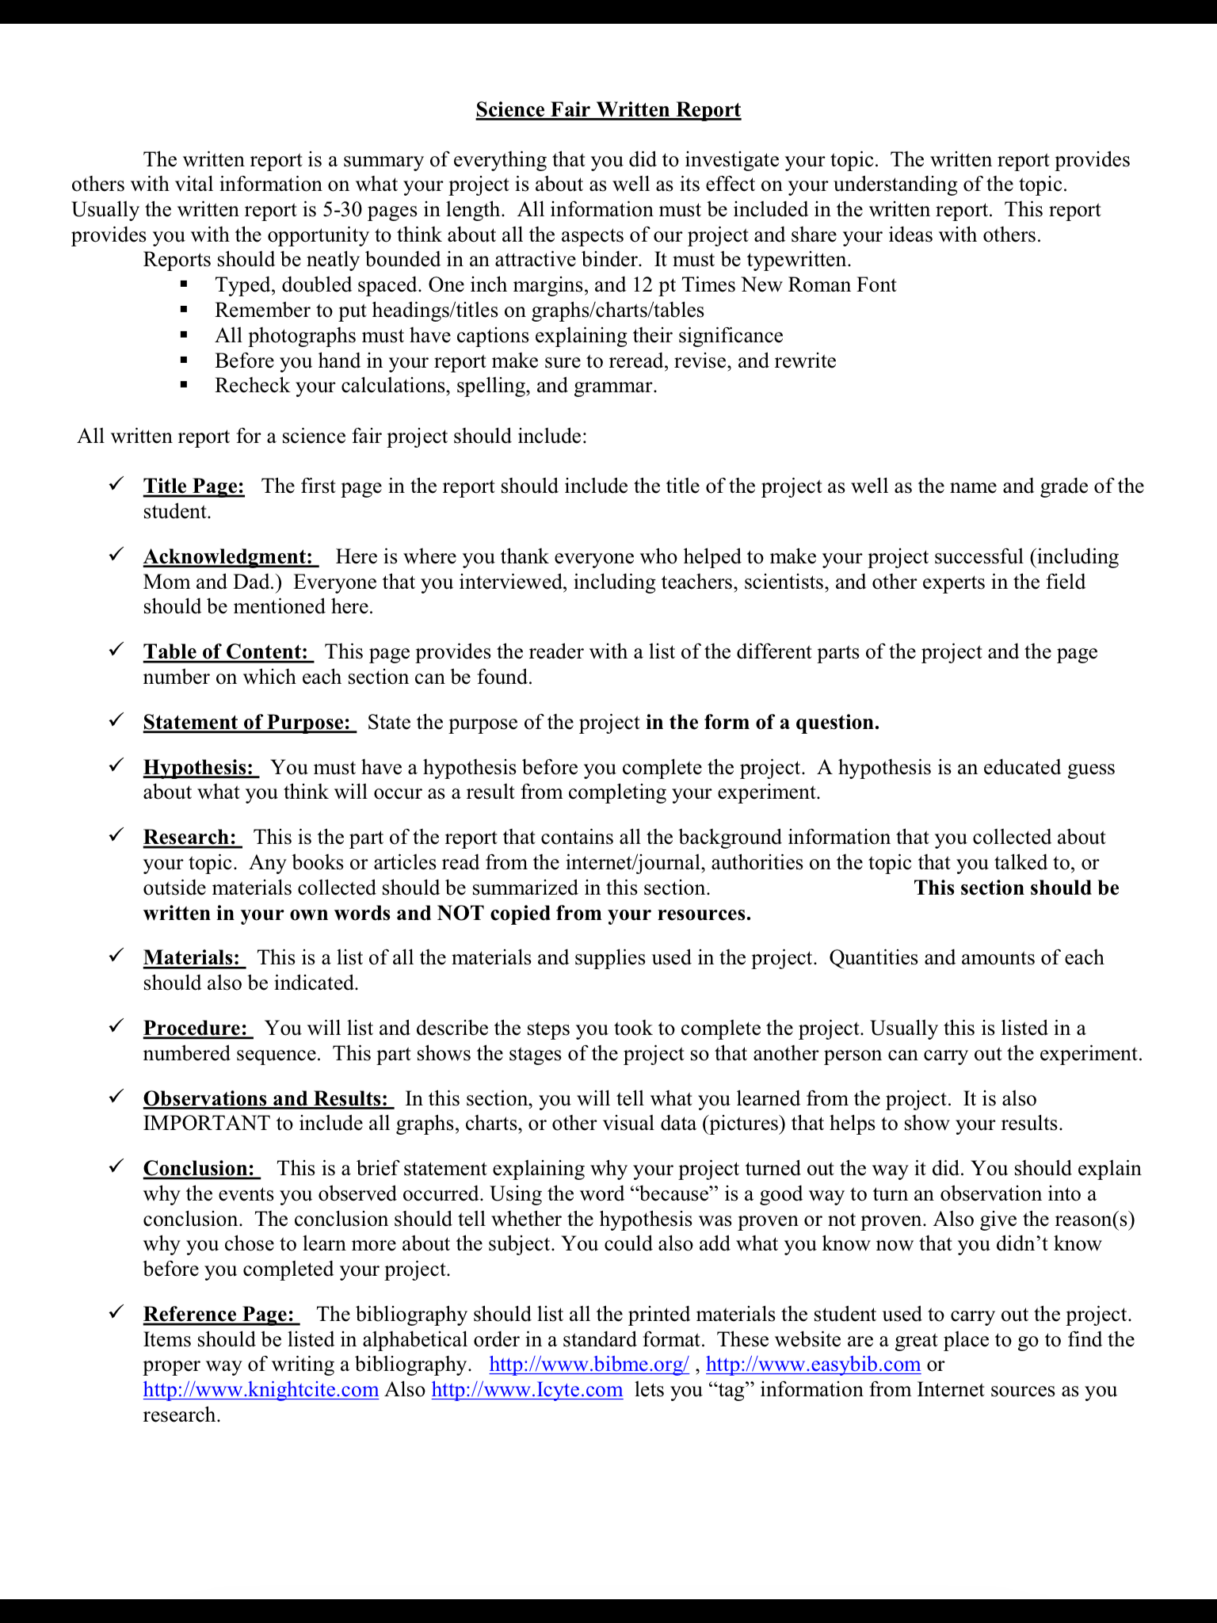

Science Project Grading Rubric

POINTS Display
____/15___ Is the display neatly organized and the design pleasing? (-1 to -5)
Are the Scientific Question, Hypothesis, Materials, Procedures, Results, and
Conclusion labeled? (-2 each)
Is there a Title If not, -5 Is it in the proper location? (-1 each)
Is the student’s name and class number below the Title? (-1 each)
Is the teacher’s name and grade level below the Title? (-1 each)
Are there at least 3 appealing pictures that pertain to the experiment? (-1 each)

____/10___ Scientific Question
Is there a Scientific Question? (-10)
Is the Scientific Question labeled? (-2)
Is the Scientific Question in the proper location? (-1)
Does the question end with a “?” (-1)
Does the question make sense? (-1 to -5)

____/10___ Hypothesis
Is there a Hypothesis? (-10)
Does the Hypothesis end with a period? (-1)
Does the Hypothesis relate to the experiment performed? (-1 to -7)
Does the Hypothesis answer the scientific question? (-5)
Does the Hypothesis make sense? (-1 to -5)

____/10___ Materials
Is there a list of materials? (-10)
Is the list of materials in the proper location? (-1)
Is it difficult to read the list? (-2)
Are all the items included that were necessary for the experiment? (-2 each)

____/10___ Procedures
Is there a list of procedures (-10)
Is the list of procedures in the proper location (-1)
Are the procedures numbered? (-2)
Does the list have fewer than 5 procedures? (-2 each <5)
Does each procedure make sense? (-1 per confusing procedure)
Can the list be followed to replicate the experiment? (-1 to -4)
Is the “Gather all materials” your first procedure? (-1)
Is “Record results” your last procedure? (-1)

____/10___ Results
Are the results on the board? (-10)
Are the results in the proper location? (-1)
Are the results displayed in table or graph form? (-9)
Are the results easy to read? (-3)
Is the table or graph constructed accurately? (-10)
If GRAPH, is the Y axis properly labeled (-2 partial, -4 not at all)
If GRAPH, is the X axis properly labeled (-2 partial, -4 not at all)
If TABLE, is the table properly labeled? (-4 partial, -8 not at all)

____/5___ TRIALS
Is there evidence of at least 3 experimental trials? (-1 for each missing trial)

____/10___ Conclusion
Is there a conclusion? (-10)
Is the conclusion in the proper location? (-1)
Does the conclusion end with something other than period? (-1)
Does the conclusion respond to the question? (-2 to -5)
Does the conclusion fit given the hypothesis? (-2 to -5)

____/10___ Background Information
Is there Background Information? (-10)
Is the Background Information in the proper location? (-1)
Is the Background Information clearly labeled using headings? (-1)
Does the Background Information speak to the experiment topic? (-1 to -9)

____/5___ Bibliography
Is there a bibliography? (-5)
Is the bibliography in the proper location? (-1)
Is the bibliography clearly labeled? (-1)
Is the bibliography accurate? (-1)

____/5___ Log or Journal (on table in front of the display)
Is there a log or journal included (scientific notes)? (-5)
Is the log hand written? (-1)
Is the log or journal clearly labeled? (-1)
Does the log or journal include all results reported regarding the experiment? (-1 to -3)

_________ Further Questions – Extra Credit (+1 to +5)
Explanation of extra points _____________________________________________________________________________________________________________________________________________________________________________
____ _____ Total Points (possible 100)

NOTE: Please check your work for spelling errors! 1-3 points will be deducted for spelling errors in each section depending upon the number and if the error is in the title/heading or simply in the body of the written work for that section. These deducted points will have a “sp” and or -___ to denote that spelling errors caused the deduction.

